Requirements for PGSuper Version II

Introduction
A new version of PGSuper is needed. WSDOT design staff has indicated the need to support Non-Composite girders. Also, more complex geometry input and output is desired to replace the “A” dimension calculations. The need for non-composite girder support is driven by anticipated design needs for upcoming projects. The “A” dimension calculations are in need of an overhaul to better reflect the geometric constraints of bridge design and construction of today. Incorrect “A” dimension and geometric modeling has lead to construction errors in the recent past.

Engineering Enhancements

Non-Composite Girders

Slab Issues
For this case, the slab becomes non-structural for longitudinal forces. The non-composite slab must still be tapered in order to compensate for girder camber.
The idea of “slab” can be replaced with the idea of “roadway surface”. The roadway surface can be composite or non-composite and can be one of the following types:
- Full depth cast in place slab
- Partial depth cast in place slab on precast deck panels
- Overlay (concrete or asphalt)

The roadway surface can be made composite or non-composite with the precast superstructure elements.

The program will continue to allow input of an additional uniform wearing surface (overlay) over the “slab”.

Girder Orientation Issues
For all but the standard I-beams, the principle axis of the girder is perpendicular to the roadway surface (at some point). For phase 1, it will be assumed that the bottom of the girder is parallel to the slab at the point of bearing of Pier 1. In phase 2, more complex geometry orientations will be supported. The complex girder orientation must locate the top plane of the girder (ignoring camber effects) parallel to the roadway surface at a particular location on the structure. From this, the slab haunch dimension along the girder will be computed such that the girder is not warped and the roadway profile is maintained.

Non-Composite Girder Types
PGSuper II will introduce the new girder types defined below.

Voided Slab Section
The voided slab section can contain 0 or more circular voids. Voids are at equal spacing. The exterior voids can be different than the interior voids. It is common for the outer-most void to be a different size (or even omitted) to accommodate reinforcing for traffic barrier connections.
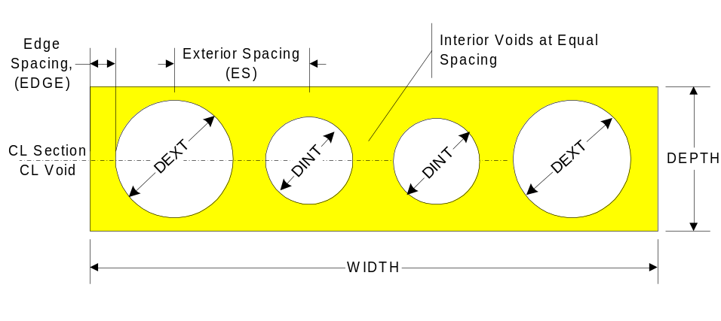

Deck Bulb Tee Section
The parametric geometry for the Deck Bulb Tee section is shown below. The top flange width (W1) varies between a minimum and maximum value.

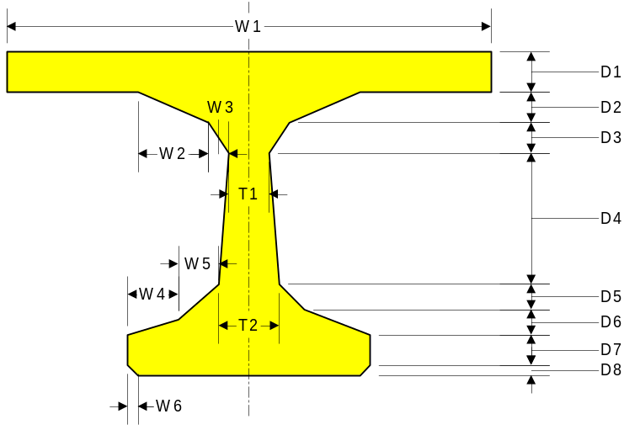

The top flange of deck bulb tees must be as wide or wider than the bottom flange (W1 ≥ 2(W4+W5) + T2).

Deck bulb tee sections can be non-composite or made composite with a cast in place concrete overlay. The composite option is commonly known as “Thin Flange Deck Bulb Tee Girders”

Ribbed Girders
The parametric geometry for ribbed girders is shown below.
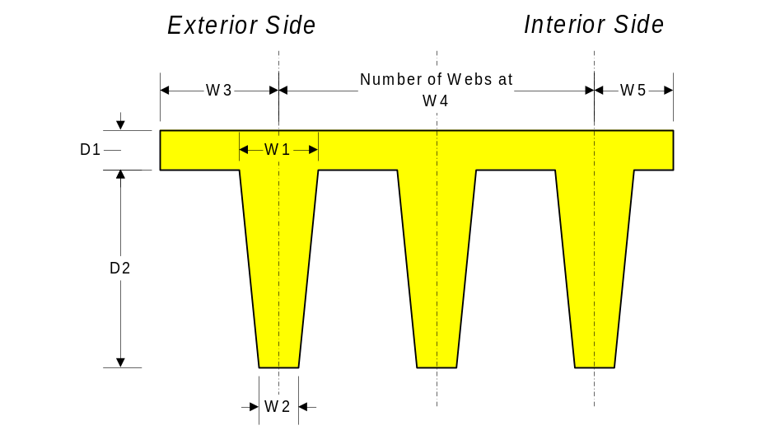

Box beams

Standard box beams. These beams are not typically used by WSDOT, however they are a standard shape in the PCI BDM. There is a minimal cost to adding this section with the payoff being support for all common beam times used throughout the United States. These beams can be adjacent to one another or spaced and used as individual beam units.
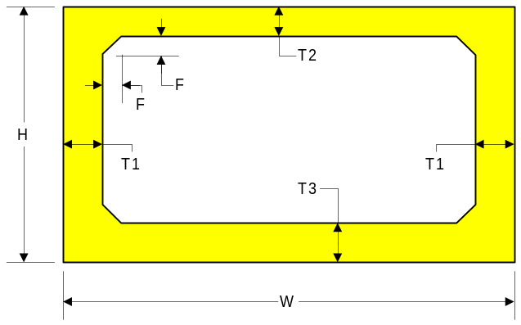

Debonding
Straight prestressing strands in PGSuper can be debonded along their length. Rules for the sequence of debonding shall be user configurable. Design for debonding will be supported. Specification checking of debonding will also be reported. A section may have both debonded and harped strands.

Horizontal Interface Shear
Change the calculation of Horizontal Interface Shear demand to be Vu/de in accordance with C5.8.4.1. WSDOT’s new details for stirrups extended from the beam to the slab result in inadequate development of the bars for horizontal shear. Adjustments will be included in the horizontal shear capacity computations to account for this.

Transformed Section Properties
Computing prestress losses and stresses based on transformed properties is a likely future code requirement. When transformed properties are used, the steel is transformed into an equivalent area of concrete. This has effects on elastic shortening loss/gain calculations.

Non-Prismatic Girders
PGSuper will be enhanced to accommodate non-prismatic girders. This will include:
- Optionally accounting for slab haunch in section stiffness
- Girders with thickened flanges (top or bottom)
- Haunched girders (variable depth sections)

LRFD 3rd Edition
PGSuper will be updated to reflect the requirements of the LRFD 3rd Edition. Support for past editions of the specification will be dropped.

Capacity of Over-Reinforced Sections
PGSuper will support the reduced capacity reduction factor (φ) method for determining the limiting capacity of over reinforced sections in addition to the methods prescribed by AASHTO LRFD. This method is presented by Seguirant, Brice, and Khaleghi and will be published in the Sept-Oct 2004 issue of PCI Journal. This method is consistent with current ACI practices.

Multiple Traffic Barriers
Allow ability to programmatically add different traffic barrier shapes in a way similar to beams. Phase I will include support for a general barrier defined by weight per unit length and slab attachment width (for distribution factor calculations). Phase II will introduce actual barrier shapes and types with sufficient detail for transverse slab design in future versions of PGSuper.

User-Defined Loads
User-Defined loads of the types given below will be supported. Loads may be applied in any of the three current bridge site stages. Loads are named by the user and must be assigned to the DC, DW, or LL+IM load cases. Loads are permanent from the stage applied. An unlimited number of loads may be applied.
The following load types will be supported.

Trapezoidal Girder Load
Trapezoidal loads may be applied at any location along a given girderline. Loads will be located from the start of the girder line using either absolute or fractional measure.

Point Load on Girder
Point loads may be applied at any location along a given girder line. Loads will be located from the start of the girder line using either absolute or fractional measure.
Point loads may be either a gravity load or a concentrated moment.

Input sequences can cause the description of a load to be located beyond the end of a girder line or on a non-existent girder line. In these situations the user will be notified and the load will be simply ignored.

User-Defined Live Loads
A user-defined live load can be defined that is applied to the Strength II limit state for ultimate capacities and the standard service limit states.

User defined live loads consists of a series of axle weight and spacing and an optional uniform load applied simultaneously with the vehicle.

User Defined Live Loads will be created and stored in the Live Load Library.

Users will specify the live load to be used during analysis by selecting Loading | Live Load. This will display the Live Load dialog. In this dialog the user will select all of the live loads that should be considered.

Non-Symmetrical Slab Overhangs
The description of slab overhangs will be improved so that non-symmetrical overhangs can be modeled. This is useful for both curved and flared roadways.
Complex slab edge geometry will also be modeled. The roadway width can be different at each end of a span. The transition can be end-to-end linear, end-to-end curved, or curved beginning at a defined distance along the span.

Elimination of ”A” Dimension
The “A” Dimension will be removed from PGSuper and replaced with detailed reporting of roadway and structural geometry. The geometry reporting will include the distance from the roadway surface to the estimated top of girder along each web line. Examples will be provided to that illustrate how to translate this data into the “A” dimension for I-beams and other required dimensions for U-beams and other girder types.Slab/Girder Interference Check
Currently, the user inputs an “A” dimension into PGSuper that is used to estimate dead loads for design and analysis. PGSuper then computes a required “A” dimension and reports the accuracy of the initial input.

The “A” dimension check will be removed and replaced with a slab/girder interference check. The distance between the top of girder and bottom of slab will be computed, accounting for camber and all geometric effects. This distance will be used to determine if the girder elevation is such that the girder does not interfere with the slab.

Compound Alignment
PGSuper will now support horizontal alignments made up of multiple curved and straight segments. Vertical alignment will consist of grade breaks and vertical curves. Superelevation transitions will be modeled. The bridge need not be placed on the centerline of the alignment. The alignment shown on bridge plans is often a survey control line, which does not necessarily run down the center of the bridge. The bridge will no longer have to be placed entirely within a horizontal or vertical curve.

Multiple Simple-Span Structure Definition
Multiple Piers can be placed at any location along the alignment. The number of girderlines is constant along the entire structure. Girder spacing is specified at the centerline of each pier. Girderline geometries must be continuously connected along bridge.

Each span is modeled as simply supported.

Loss Calculations in Accordance with LRFD, WSDOT BDM, and NCHRP 496
PGSuper will have several models for loss calculations. This will include the LRFD method, WSDOT BDM method, and the methods of NCHRP 496 which will likely become the new LRFD requirements.

Analysis of Continuous Structures
Although we will continue to design the girders for simple span behavior, we will report continuous span results for design of the deck reinforcing. Also, we will envelope the continuous and simple span shear loads for shear design and analysis.

In the future, we can count on continuity for girder design if need be.

Slab Analysis Design
Analyze and design Stay-in-Place deck panels and cast-in-place designs for longitudinal and transverse effects.

Bearing Pad Analysis Design
Design and analyze elastomeric bearing pads

Mild-Reinforcing Materials
PGSuper will accommodate user defined mild reinforcing steel for transverse and longitudinal reinforcement

User Interface Enhancements

Remove Concrete Library
Concrete material properties are to be specified explicitly by user

Remove Connections Library
Connection details will be specified by the user directly as input. Standard connections will be stored in a library and can be copied into a project. There will not be a relationship between the library entries and the user input after the data is copied.

Reporting
The presentation of reports needs a complete overhaul. Reports need to be formatted to fit on printed-paper and be saved to disk.

User-Configurable Reports
PGSuper will continue to be shipped with stock reports. However, users will also be able create custom reports of their own by adding existing chapters in a specified sequence to a report definition. Custom reports can be recalled by name and be persisted between project files.

Girder Geometry View Within Library
An option will be supported to allow viewing of the girder geometry and strand geometry within the girder library editor.

Point of Reference for Strand Layout in Library
The current point of reference for strand layout in a cross section is the bottom of the section. It would be better if harped strands were defined, at the ends of the section, from the top down. The goal is to allow a change in girder height and the harped strands would remain in the same relative location from the top of the girder. This is a little more complex with the included webs of the trapezoidal box beams, but I think we understand the idea.

Custom Icons For Each Library Entry
Currently all items in a library must have the same display icon. This becomes confusing to users when many entries are in the library. Icons base on individual entries shall be supported.

Subfolders within Library
To facilitate library organization, the library editor will support multiple sub-folders within a library. The user can name the subfolders.

Import of Library Entries Into Master Library
The current library editor does not allow you to import entries from other library files or from project files. This feature should be added.

New methods for specifying strands in U-girders
Currently it is difficult to enter strand coordinates for U-girders and any girders that are expected to vary in a non-standard manner. This needs to be made easier

Stress Profile View
It would be much easier to design the correct number of strands in a girder if we had a view that displayed the profile of stress limit states along the girder. This could be done using a capacity/demand ratio to normalize limit state values.

Computation of Roadway Area
Add this value to reports to help users compute uniform girder loads due to a uniform load applied to the entire deck.

Development Phases
Development will occur in three phases as outlined below.

Phase 1
Using the current geometric bridge model, add new “A” dimension calculations, non-composite beams and debonding.

Phase 2
Update roadway and bridge geometry. Roadway geometry will include complex horizontal and vertical alignments (bridge not entirely within curves, super-elevation transitions, compound vertical curves, etc). Bridge geometry will consist of a multi-span definition of the structure including non-parallel girder lines.

Phase 3
Implementation of other requirements

Installation
The PGSuper installer shall be upgraded to current “MSI” technology required by WSDOT OIT.

